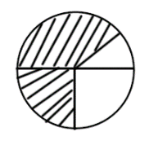LI – Revision of fraction problems (circle)

1) One third and one quarter of this circle is shaded. What fraction of the circle is shaded?

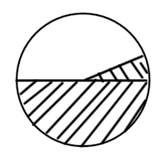

2) One half and one sixth of the circle is shaded What fraction of the circle is not shaded?

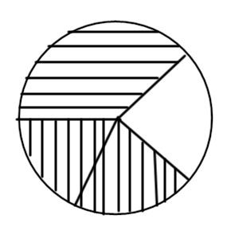

3) Two fifths and one third of the circle is shaded. What fraction of the circle is shaded?

4) One quarter and two tenths are shaded. What fraction of the circle is not shaded?

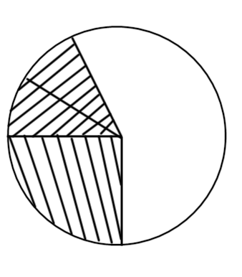

5) 20% and 60% of the circle is shaded. What fraction of the circle is shaded?

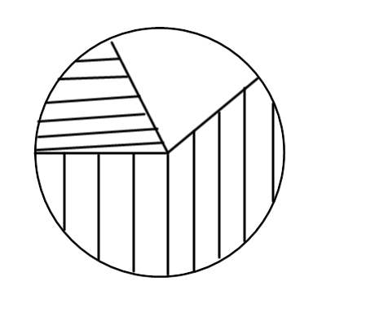

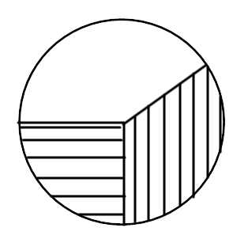

6) 0.4 and 25% of the circle is shaded. What fraction of the circle is not shaded?

7) One tenth, 50% and 0.25 of the circle is shaded. What fraction of the circle is shaded?

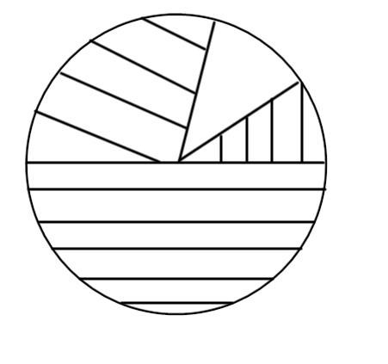

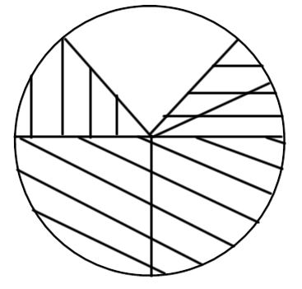

8) Two twelfths, two quarters and one sixth of the circle is shaded. What fraction of the circle is shaded?