1) Write these fractions as mixed number and then work out what they are as improper fractions
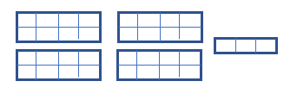
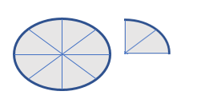
1) Write these fractions as mixed number and then work out what they are as improper fractions
1) Write these fractions as mixed number and then work out what they are as improper fractions

1) Write these fractions as mixed number and then work out what they are as improper fractions
