3 – timetable problems
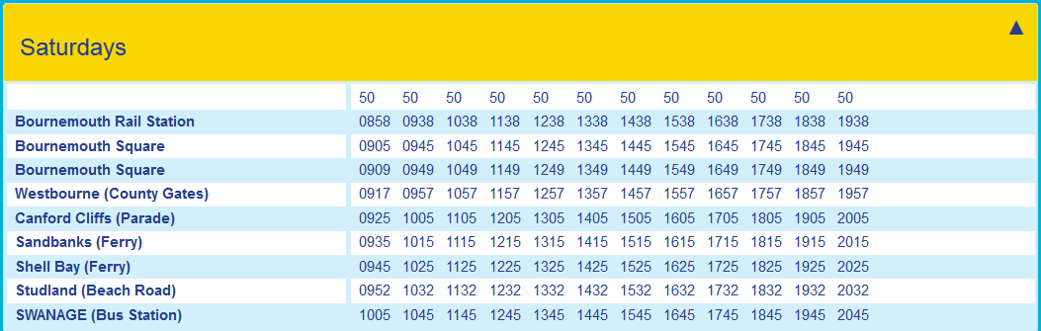

1. How long does the bus take to get from Canford Cliffs to Swanage?
2. How long does the bus take to get from Bournemouth Rail Station to Sandbanks Ferry?
3. What is the latest bus I could get from Bournemouth Square to get to Shell Bay by half past one?
4. If the 9:38 bus from Bournemouth Rail Station was running 13 minutes late, what time might you expect it to arrive in Swanage?
5. If the 14:57 from Westbourne was running 20 minutes late, and then made up 6 minutes on its route, what time would you expect it to arrive in Swanage?
6. Why do you think Bournemouth Square is on the timetable twice? Explain your answer.
7. What time does the first bus of the day leave on 1st May 2018? Explain your answer.

3 – timetable problems

1. How long does the bus take to get from Canford Cliffs to Swanage?
2. How long does the bus take to get from Bournemouth Rail Station to Sandbanks Ferry?
3. What is the latest bus I could get from Bournemouth Square to get to Shell Bay by half past one?
4. If the 9:38 bus from Bournemouth Rail Station was running 13 minutes late, what time might you expect it to arrive in Swanage?
5. If the 14:57 from Westbourne was running 20 minutes late, and then made up 6 minutes on its route, what time would you expect it to arrive in Swanage?
6. Why do you think Bournemouth Square is on the timetable twice? Explain your answer.
7. What time does the first bus of the day leave on 1st May 2018? Explain your answer.

