Year 6 mistakes - explain how you know they are wrong (2)
Use your reasoning detective skills to explain the mistakes in these calculations (do not just calculate the answer)
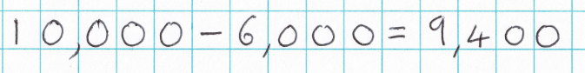

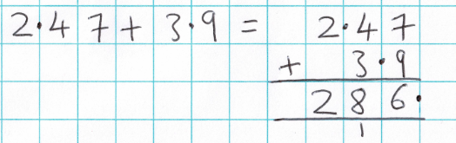

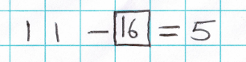

Year 6 mistakes - explain how you know they are wrong (2)
Use your reasoning detective skills to explain the mistakes in these calculations (do not just calculate the answer)

