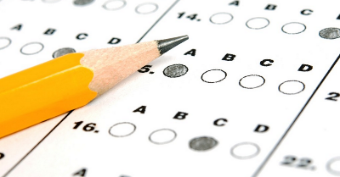
3 Percentage Problem 1
Is scoring 40/80 or achieving 45% better in a test?
Explain your answer!
I know that…..

3 Percentage Problem 2
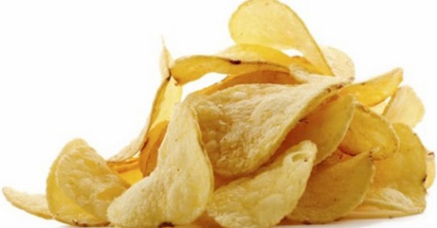
Which is the best deal:
50% off a multipack of 12 packets of crisps normally £3.70
3 for 2 on the same crisps costing 80p per packet
Explain your answer!
I know that…..

3 Percentage Problem 3
Amy and Judy shared 25% of a 1 kg bar of chocolate. Amy ate a 30% of the amount that Jude ate. How much did they each eat?
Explain your answer

