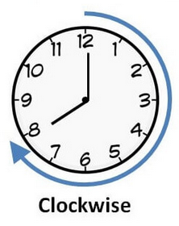 Clockwise and anticlockwise 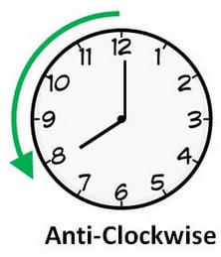

7
6

8
F

5
4

3
2

S
1

Follow the path and label each turn as clockwise (c) or anticlockwise (a)

1 2 3 4

5 6 7 8

