1. Whole numbers (integers) x fractions
Draw a method to calculate (the first two have been started for you)
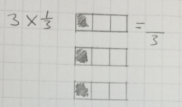
1) $3 x \frac{1}{3}$ =

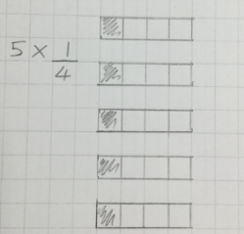
2) $5 x \frac{1}{4}$ =
3) $6 x \frac{2}{3}$ =
4) $3 x \frac{4}{5}$ =
5) $2 x \frac{1}{10}$ =
6) $9 x \frac{5}{8}$ =
7) $4 x \frac{5}{6}$ =
8) $5 x \frac{4}{5}$ =

1. Whole numbers (integers) x fractions
Draw a method to calculate (the first two have been started for you)
1) $3 x \frac{1}{3}$ =

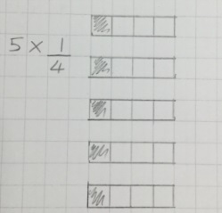
2) $5 x \frac{1}{4}$ =
3) $6 x \frac{2}{3}$ =
4) $3 x \frac{4}{5}$ =
5) $2 x \frac{1}{10}$ =
6) $9 x \frac{5}{8}$ =
7) $4 x \frac{5}{6}$ =
8) $5 x \frac{4}{5}$ =

1. Whole numbers (integers) x fractions
Draw a method to calculate (the first two have been started for you)
1) $3 x \frac{1}{3}$ =

2) $5 x \frac{1}{4}$ =
3) $6 x \frac{2}{3}$ =
4) $3 x \frac{4}{5}$ =
5) $2 x \frac{1}{10}$ =
6) $9 x \frac{5}{8}$ =
7) $4 x \frac{5}{6}$ =
8) $5 x \frac{4}{5}$ =

1. Whole numbers (integers) x fractions
Draw a method to calculate (the first two have been started for you)
1) $3 x \frac{1}{3}$ =

2) $5 x \frac{1}{4}$ =
3) $6 x \frac{2}{3}$ =
4) $3 x \frac{4}{5}$ =
5) $2 x \frac{1}{10}$ =
6) $9 x \frac{5}{8}$ =
7) $4 x \frac{5}{6}$ =
8) $5 x \frac{4}{5}$ =

